DBUZ – Bus Ticketing System
MINOR PROJECT REPORT

Submitted by

VEDANT S (RA2311026010436)

ARYAN K (RA2311026010441)
Under the Guidance of

Dr. Sheryl Oliver A
(Assistant Professor, Department of Computational Intelligence)

in partial fulfillment of the requirements for the degree of

BACHELOR OF TECHNOLOGY
in
COMPUTER SCIENCE ENGINEERING
with specialization in (DATA SCIENCE)


DEPARTMENT OF DATA SCIENCE AND BUSINESS SYSTEMS COLLEGE OF ENGINEERING AND TECHNOLOGY
SRM INSTITUTE OF SCIENCE AND TECHNOLOGY
KATTANKULATHUR- 603 203
MAY 2025


SRM INSTITUTE OF SCIENCE AND TECHNOLOGY KATTANKULATHUR – 603 203

BONAFIDE CERTIFICATE

Certified that 21CSC205P - Project report titled “Roadway – Bus Management System” is the Bonafide work of “Vedant Singh (RA2311026010436), Aryan Khanna (RA2311026010441)” who carried out the project work under my supervision. Certified further, that to the best of my knowledge the work reported herein does not form any other project report or dissertation on the basis of which a degree or award was conferred on an earlier occasion on this or any other candidate.

SIGNATURE SIGNATURE

Dr. Sheryl Oliver A
Assistant Professor
Department of CINTEL
SRM Institute of Science and Technology Kattankulathur
Dr. Annie Uthra R
Professor and Head
Department of CINTEL
SRM Institute of Science and Technology Kattankulathur

Abstract

The Smart Bus Ticketing App Project is an innovative software solution designed to modernize and simplify public transportation ticketing and travel management. This project provides passengers with a convenient and intuitive platform for booking bus tickets, tracking buses in real-time, viewing travel history, and accessing detailed route and schedule information.

At its core, the system leverages a robust Database Management System (DBMS) to store, organize, and process critical data related to bus schedules, passenger bookings, route information, vehicle tracking, and user history. The use of a DBMS ensures reliable data handling, secure access, and efficient retrieval mechanisms, enabling seamless integration of various services within the app.

The Smart Bus Ticketing App offers multiple advantages. Firstly, it enhances passenger safety and convenience through real-time bus tracking and route updates. Secondly, it improves the efficiency of ticket management by providing digital booking and maintaining complete ticketing history. Thirdly, the system supports scalability and high user concurrency, making it suitable for expanding transport networks. With secure user authentication, data privacy measures, and an interactive interface, this app represents a significant step towards smarter, data-driven public transportation systems.

TABLE OF CONTENTS

CHAPTER NO | CHAPTER NAME | PAGE NO.
1 | Problem understanding, Identification of Entity and Relationships,  Construction of DB using ER Model for the project | 1
2 | Design of Relational Schemas, Creation of Database Tables for the  project | 8
3 | Complex queries based on the concepts of constraints, sets, joins,  views, Triggers and Cursors | 11
4 | Analysing the pitfalls, identifying the dependencies, and applying  normalizations | 18
5 | Implementation of concurrency control and recovery mechanisms | 21
6 | Code for the project | 24
7 | Result and Discussion (Screen shots of the implementation with front  end) | 30
8 | Conclusion | 33
9 | Attach the Real Time project certificate / Online course certificate

PROBLEM UNDERSTANDING, IDENTIFICATION OF ENTITY AND RELATIONSHIPS, CONSTRUCTION OF DB USING ER MODEL FOR THE PROJECT

Problem Understanding

Inefficient Booking Processes
Manual or semi-digital booking systems lead to long queues, delays, and limited transparency on seat availability.

Lack of Real-Time Information
Passengers often lack real-time updates on bus locations, arrivals, and delays, resulting in uncertainty and inconvenience.

Limited Route Optimization
Traditional route planning does not account for real-time traffic, road conditions, or shortest travel paths, causing longer travel times.

Overcrowding and Poor Load Management
Buses may be underutilized or overcrowded due to poor visibility into passenger demand and lack of predictive analytics.

Uncoordinated Fleet Management
Transportation authority’s lack centralized control over vehicle movements, making it difficult to optimize schedules and manage fleets efficiently.

Poor Decision-Making for Urban Planning
Inadequate data on commuter patterns and traffic flow restricts authorities from making informed infrastructure and route decisions.

Inconvenient Rescheduling and Cancellations
Passengers face difficulty in modifying bookings, often requiring physical presence or tedious processes.

Inaccessibility for Remote Users
Users in rural or remote areas may lack access to updated transport information, leading to inconsistent travel experiences.

Environmental Impact Due to Fuel Wastage
Inefficient routes and idle buses increase fuel consumption and emissions, contributing to environmental degradation.

Lack of Integration with Smart City Goals
Current transportation systems are not aligned with smart city initiatives that focus on automation, efficiency, and sustainability.

Identification Of Entities And Relationships

Entities and Their Attributes

Passenger
Attributes: ID, Name, Age, Phone

Booking
Attributes: B_ID (Booking ID)

Bus Info
Attributes: bus_no, Time, seats, Available seat, destination

Route Info
Attributes: route_id, Pickup point

Ticket
Attributes: Ticket Info, Validity

Payment
Attributes: P_ID (Payment ID), Amount, date, method

Notification
Attributes: message

Review
Attributes: B_ID, Comment, rating

Cancellation
Attributes: B_ID, refund amount, date

Relationships Between Entities

Passenger –[services]→ Booking
A passenger can make bookings (1-to-many).

Passenger –[make]→ Notification
A passenger receives notifications.

Booking –[have]→ Payment
A booking has one payment record.

Booking –[give]→ Ticket
A booking generates a ticket.

Booking –[Info]→ Bus Info
A booking is linked with bus details.

Bus Info [travel through] → Route Info
A bus travels along a specific route.

Booking –[B_ID] → Cancellation
A booking can be associated with a cancellation.

Booking –[B_ID] → Review
A booking can be reviewed by the user.

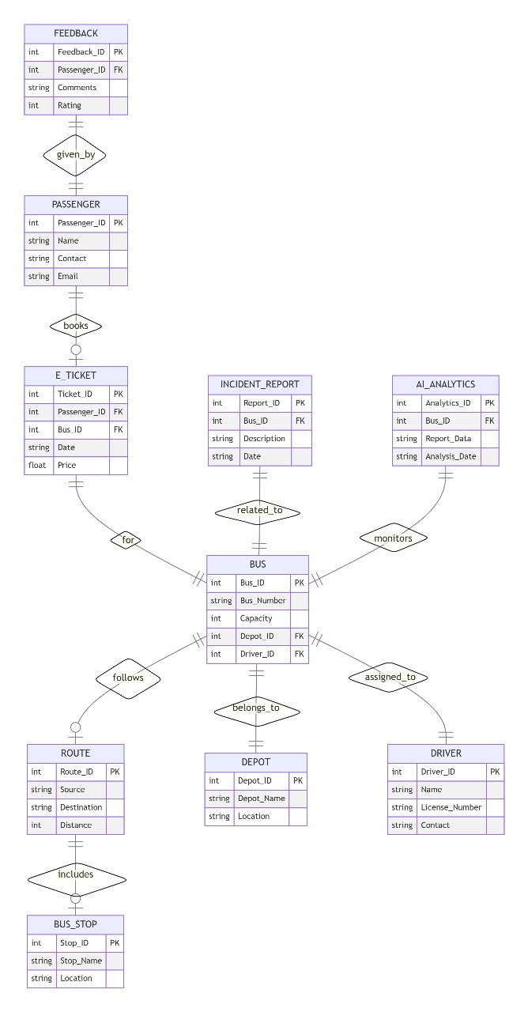

Construction of DB using ER Model for the project

Purpose
To design and construct a relational database for the DBUZ-Bus Ticketing System based on the ER diagram provided. The database will store passenger information, booking details, bus and route info, ticketing, payments, notifications, reviews, and cancellations.

Key Entities and Table Structures
Below are the main tables to be constructed from the ER model, along with their key fields and relationships:

Relationship | Type | Description
Passenger → Booking | One-to-Many | A passenger can make many bookings
Booking → Payment | One-to-One | Each booking has one payment
Booking → Ticket | One-to-One | Each booking gives one ticket
Booking → Bus_Info | Many-to-One | Multiple bookings can be for one bus
Bus_Info → Route | Many-to-One | Each bus travels on a specific route
Booking → Cancellation | Optional One-to-One | A booking may be cancelled
Booking → Review | Optional One-to-One | A booking may have a review
Passenger → Notification | One-to-Many | Each passenger can receive multiple notifications

- Passenger Table
Description: Stores details of users who make bookings.

Fields:
  - passenger_id – Unique ID for each passenger (Primary Key).
  - name – Name of the passenger.
  - age – Age of the passenger.
  - phone – Contact number of the passenger.

Booking Table
Description: Records every booking made by a passenger.

Fields:
  - booking_id – Unique booking identifier (Primary Key).
  - passenger_id – Links to the passenger who made the booking (Foreign Key).
  - bus_no – Bus booked (Foreign Key to Bus_Info).
  - ticket_id – Associated ticket (Foreign Key).

  - payment_id – Related payment entry (Foreign Key).

Bus_Info Table
Description: Maintains all the operational and capacity details of buses.

Fields:
  - bus_no – Unique bus identifier (Primary Key).
  - time – Departure time of the bus.
  - seats – Total number of seats in the bus.
  - available_seat – Number of currently available seats.
  - destination – Final stop for the bus.
  - route_id – Route taken by the bus (Foreign Key).

Route_Info Table
Description: Stores data about bus routes and pickup points.

Fields:
  - route_id – Unique route identifier (Primary Key).
  - pickup_point – Starting or intermediate stop of the route.

Ticket Table
Description: Contains ticket details generated after a booking.

Fields:
  - ticket_id – Unique ticket identifier (Primary Key).
  - ticket_info – Encoded/printed ticket data.
  - validity – Date or duration till which ticket is valid.

Payment Table
Description: Handles all payment-related records for bookings.

Fields:
  - payment_id – Unique payment identifier (Primary Key).
  - booking_id – Booking for which payment was made (Foreign Key).
  - amount – Amount paid.
  - date – Date of payment.
  - method – Mode of payment (e.g., UPI, card).

Notification Table
Description: Stores messages sent to users about bookings, cancellations, or updates.

Fields:
  - notification_id – Unique notification ID (Primary Key).
  - passenger_id – Recipient passenger (Foreign Key).

  - message – Content of the notification.

Review Table
Description: Captures passenger feedback and rating for the service or trip.

Fields:
  - review_id – Unique ID for each review (Primary Key).
  - booking_id – Booking associated with the review (Foreign Key).
  - comment – Passenger’s written feedback.
  - rating – Numerical rating given by the user.

Cancellation Table
Description: Records information related to booking cancellations.

Fields:
  - cancel_id – Unique ID for cancellation record (Primary Key).
  - booking_id – Booking that was cancelled (Foreign Key).
  - refund_amount – Amount refunded to the user.
  - date – Date of cancellation.

ER to Relational Schema Conversion Summary
Each entity in the ER model is converted into a table. Relationships are implemented using foreign keys. The system handles optional relationships (like cancellation or reviews) with nullable foreign keys or separate tables.

Normalization
1NF: All attributes contain only atomic values (e.g., no lists).
2NF: All non-key attributes are fully functionally dependent on the primary key.
3NF: No transitive dependencies; related data is separated into different tables.

DESIGN OF RELATIONAL SCHEMAS, CREATION OF DATABASE TABLES FOR THE PROJECT

-- Creating the database
CREATE DATABASE BusBookingSystem;

-- Step 2: Use the newly created database USE BusBookingSystem;

-- Creating the tables

-- Table: Booking
CREATE TABLE Booking (
Bid INT AUTO_INCREMENT PRIMARY KEY
);

-- Table: Passenger
CREATE TABLE Passenger (
id INT AUTO_INCREMENT PRIMARY KEY, phone VARCHAR(15),
name VARCHAR(100),
gender ENUM('Male', 'Female', 'Other'), age INT
);

-- Table: Ticket
CREATE TABLE Ticket (
id INT AUTO_INCREMENT PRIMARY KEY,
validity BOOLEAN, ticket_info TEXT
);

-- Table: Review
CREATE TABLE Review (
review_id INT AUTO_INCREMENT PRIMARY KEY, Bid INT,
comment TEXT, rating INT,
FOREIGN KEY (Bid) REFERENCES Booking(Bid) ON DELETE CASCADE

);

-- Table: Cancellation
CREATE TABLE Cancellation (
cancellation_id INT AUTO_INCREMENT PRIMARY KEY, Bid INT,
refund_amount DECIMAL(10, 2), cancellation_date DATE,
FOREIGN KEY (Bid) REFERENCES Booking(Bid) ON DELETE CASCADE
);

-- Table: Date
CREATE TABLE Date (
date_id INT AUTO_INCREMENT PRIMARY KEY, amount DECIMAL(10, 2),
method VARCHAR(50), pid INT,
FOREIGN KEY (pid) REFERENCES Passenger(id) ON DELETE CASCADE
);

-- Table: BusInfo
CREATE TABLE BusInfo (
bus_no INT AUTO_INCREMENT PRIMARY KEY,
time TIME,
destination VARCHAR(100), seat_no INT,
available_seat INT
);

-- Table: RouteInfo
CREATE TABLE RouteInfo (
route_id INT AUTO_INCREMENT PRIMARY KEY,
pickup_point VARCHAR(100), drop_point VARCHAR(100)
);

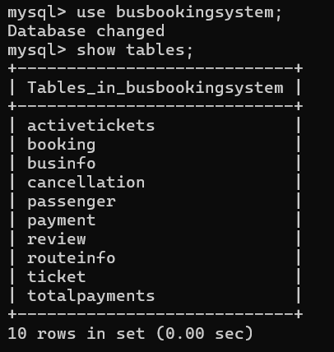

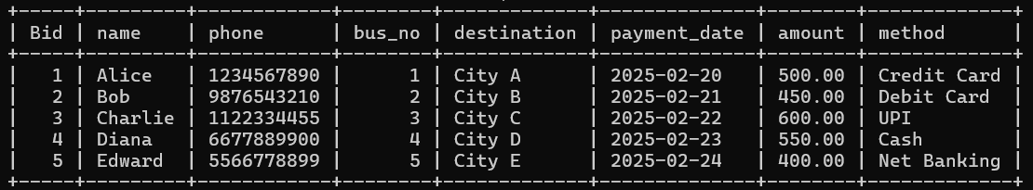

COMPLEX QUERIES BASED ON THE CONCEPTS OF CONSTRAINTS, SETS, JOINS, VIEWS, TRIGGERS AND CURSORS

Constraints - Ensuring Refund Amount is Always Positive
ALTER TABLE Cancellation
ADD CONSTRAINT chk_refund_positive CHECK (refund_amount >= 0);

Set Operations - Find Passengers Who Have Booked But Not Canceled
SELECT P.id, P.name FROM Passenger P
JOIN Booking B ON P.id = B.Bid
LEFT JOIN Cancellation C ON B.Bid = C.Bid WHERE C.Bid IS NULL;

Joins - Retrieve Full Booking Information with Passenger and Payment Details
SELECT B.Bid, P.name, P.phone, Py.payment_date, Py.amount, Py.method FROM Booking B
JOIN Passenger P ON B.Bid = P.id
LEFT JOIN Payment Py ON P.id = Py.pid;

Views - Create Views for Frequently Used Queries
CREATE VIEW ActiveTickets AS
SELECT B.Bid, P.name, T.ticket_info, T.validity FROM Booking B
JOIN Passenger P ON B.Bid = P.id JOIN Ticket T ON B.Bid = T.id WHERE T.validity = TRUE;

Trigger - Automatically Insert a Cancellation Entry When a Ticket is Invalid
DELIMITER //
CREATE TRIGGER AutoCancelInvalidTicket AFTER UPDATE ON Ticket
FOR EACH ROW BEGIN
IF NEW.validity = FALSE THEN
INSERT INTO Cancellation (Bid, refund_amount, cancellation_date) VALUES (NEW.id, 200.00, CURDATE());
END IF;

END;
// DELIMITER ;

Cursor - Retrieve and Print All Available Bus Details
DELIMITER //
CREATE PROCEDURE ListAvailableBuses() BEGIN
DECLARE done INT DEFAULT 0;
DECLARE bus_no INT;
DECLARE destination VARCHAR(100); DECLARE available_seat INT;

DECLARE bus_cursor CURSOR FOR
SELECT bus_no, destination, available_seat FROM BusInfo WHERE available_seat > 0; DECLARE CONTINUE HANDLER FOR NOT FOUND SET done = 1;
OPEN bus_cursor;

read_loop: LOOP
FETCH bus_cursor INTO bus_no, destination, available_seat; IF done = 1 THEN
LEAVE read_loop;
END IF;
SELECT CONCAT('Bus No: ', bus_no, ' to ', destination, ' has ', available_seat, ' seats available.') AS Bus_Info;
END LOOP;

CLOSE bus_cursor; END;
// DELIMITER ;


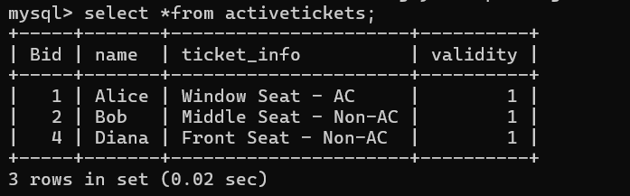
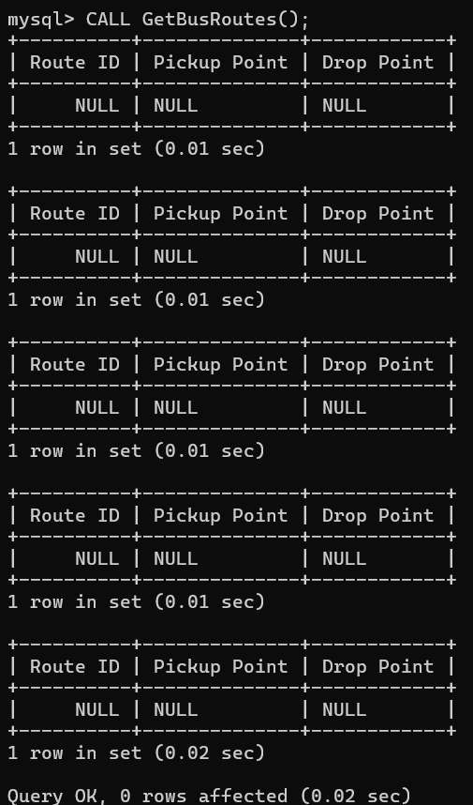

ANALYSING THE PITFALLS, IDENTIFYING THE DEPENDENCIES, AND APPLYING NORMALIZATIONS

Analysing The Pitfalls
Creating a relational database for a bus reservation system involves various challenges and pitfalls that can affect its efficiency, consistency, and usability. Below are potential pitfalls, their explanations, and possible solutions:

Data Redundancy
- Issue: Redundant data can occur if the database design does not follow normalization principles. For instance, storing bus details (like BusNo, Route, and Seats) repeatedly in the Booking table leads to unnecessary duplication.
- Impact: Increases storage requirements and the risk of data inconsistency (e.g., updating bus details in one place but not elsewhere).
- Solution: Normalize the database to at least 3NF or BCNF to minimize redundancy. Store bus-related details in a separate BusInfo table, and use foreign keys in related tables.

Complex Joins
- Issue: Normalization can result in highly fragmented data spread across many tables, requiring complex joins to fetch information (e.g., fetching passenger details, booking info, and route in one query).
- Impact: Decreases query performance and makes the database harder to maintain.
- Solution: Use denormalized views or caching mechanisms for frequently accessed data.

Limited Scalability
- Issue: The database may struggle to handle high volumes of concurrent bookings or queries as the system grows.
- Impact: Slow performance and possible downtime.
- Solution: Use horizontal scaling (sharding), indexing, or move to distributed databases (e.g., MySQL Cluster or PostgreSQL with partitioning).

Lack of Referential Integrity
- Issue: Foreign key relationships might not be enforced or validated properly. For instance, bookings may refer to non-existent buses or passengers.
- Impact: Leads to orphan records and inconsistent data.
- Solution: Define foreign key constraints and use triggers to enforce integrity rules.

Inefficient Indexing

- Issue: Failure to create proper indexes on frequently searched columns (e.g., BusNo, PassengerID, or RouteID).
- Impact: Slows down queries, especially when dealing with large datasets.
- Solution: Add indexes to high-read columns but avoid over-indexing, which can slow down write operations.

Hard-Coding Constraints
- Issue: Business rules, such as max seats per bus or valid routes, might be hard-coded in the application rather than in the database.
- Impact: Makes the system inflexible and harder to maintain.
- Solution: Use check constraints, triggers, or reference tables in the database to enforce business rules.

Failure to Handle Multivalued Dependencies
- Issue: A bus may have multiple schedules and routes, creating multivalued dependencies in a single table.
- Impact: Data anomalies and redundancy.
- Solution: Normalize the database to 4NF, splitting schedules and routes into separate tables.
.

Handling Dynamic Pricing
- Issue: Prices for tickets might change based on demand, requiring constant updates.
- Impact: Stale or incorrect pricing in the system.
- Solution: Use a PricingRules table or a dynamic pricing API to calculate ticket prices on the fly.

Limited Support for Multi-Language Input
- Issue: If the system doesn't handle Unicode properly, names or locations in different languages might not be stored correctly.
- Impact: Reduces usability for users from diverse linguistic backgrounds.
- Solution: Use a UTF-8 character set for all text columns.

Incomplete Testing
- Issue: Failure to test edge cases, such as simultaneous bookings, cancellations, or database crashes.
- Impact: Unexpected errors in production.
- Solution: Thoroughly test the database under load and simulate real-world scenarios.

Identifying The Dependencies

Booking Table Schema:
Bid → {} (No other attributes; Bid is the only column.)

Dependencies:
  - Trivial Dependency: Bid → Bid (Identity)
  - Primary Key: Bid ensures each record is unique.

Passenger Table Schema:
Id → {Name, Phone, Gender, Age}

Dependencies:
  - Id → Name, Phone, Gender, Age
Each passenger is uniquely identified by their Id.

Trivial Dependency:
{Id, Name, Phone, Gender, Age} → {Id, Name, Phone, Gender, Age}

Ticket Table Schema:
Tid → {Validity, TicketInfo}

Dependencies:
  - Tid → Validity, TicketInfo
Each ticket is uniquely identified by Tid.

Trivial Dependency:
{Tid, Validity, TicketInfo} → {Tid, Validity, TicketInfo}

Review Table Schema:
ReviewId → {Bid, Comment, Rating} Bid → {Comment, Rating} Dependencies:
  - ReviewId → Bid, Comment, Rating
A review is uniquely identified by ReviewId.
  - Bid → Comment, Rating
A booking can have one or more reviews.

Cancellation Table Schema:
Cid → {Bid, RefundAmount, CancellationDate} Bid → {RefundAmount, CancellationDate} Dependencies:
  - Cid → Bid, RefundAmount, CancellationDate A cancellation is uniquely identified by Cid.
  - Bid → RefundAmount, CancellationDate
A booking can have at most one cancellation.

Payment Table Schema:
Pid → {Date, Amount, Method, PassengerId} PassengerId → {Pid} (1:N relationship) Dependencies:
  - Pid → Date, Amount, Method, PassengerId A payment is uniquely identified by Pid.
  - PassengerId → {Pid}
Each passenger can make multiple payments.

BusInfo Table Schema:
BusNo → {Time, Destination, SeatNo, AvailableSeat}

Dependencies:
  - BusNo → Time, Destination, SeatNo, AvailableSeat Each bus is uniquely identified by BusNo.

RouteInfo Table Schema:
RouteId → {PickupPoint, DropPoint}

Dependencies:
  - RouteId → PickupPoint, DropPoint
Each route is uniquely identified by RouteId.

Applying Normalizations

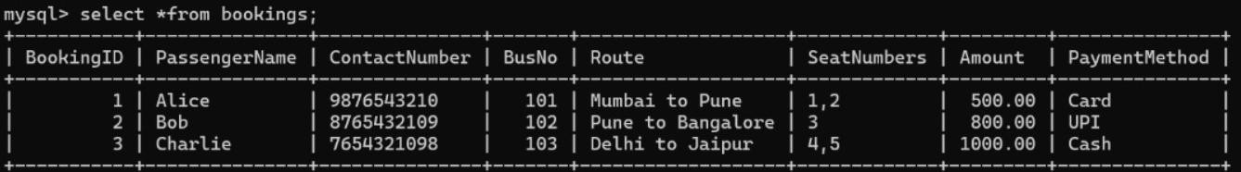
Base table:

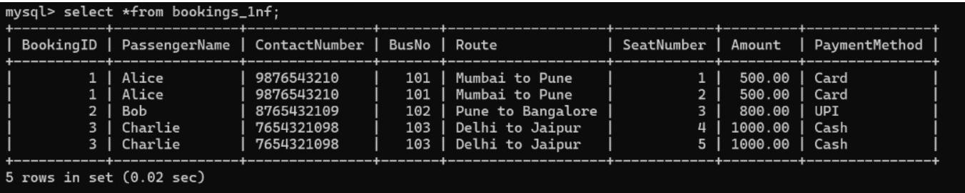
1NF:

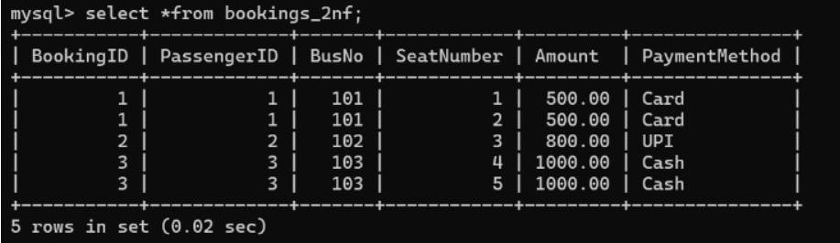
2NF:

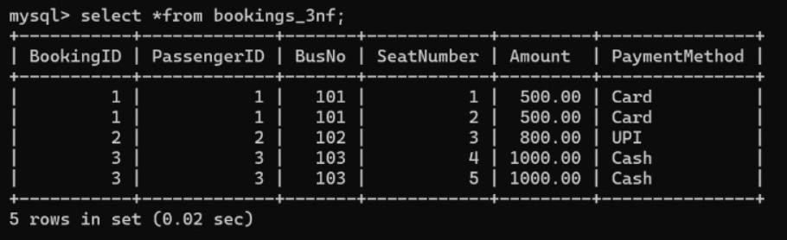
3NF:

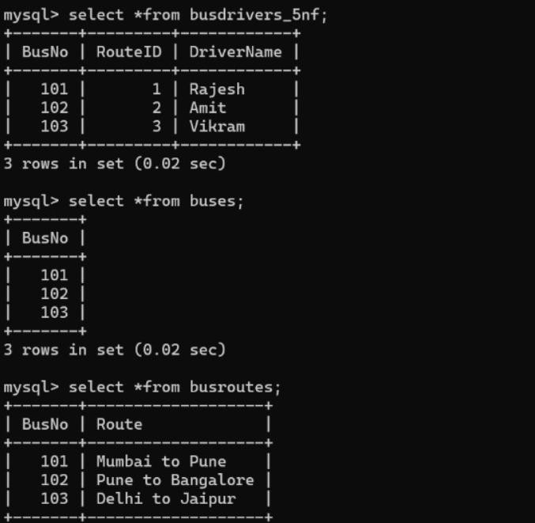
BCNF:

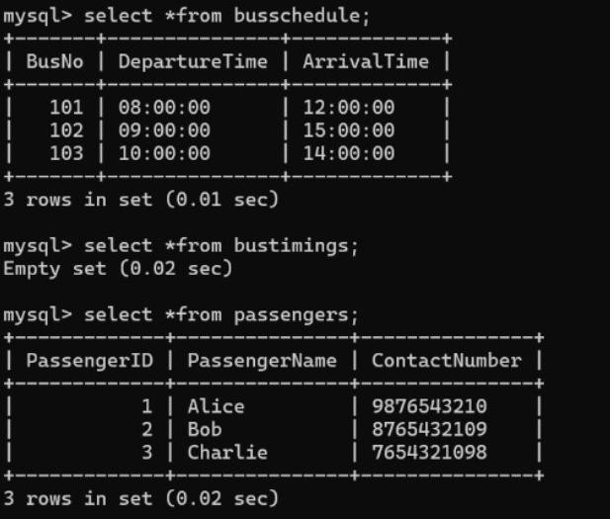
4NF:

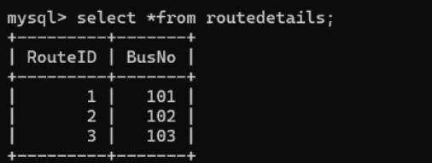
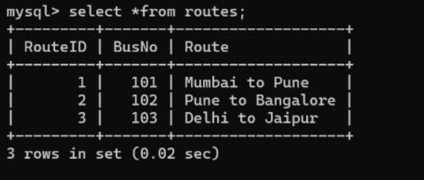
5NF:

IMPLEMENTATION OF CONCURRENCY CONTROL AND RECOVERY MECHANISMS

Concurrency Control
Concurrency control ensures that multiple transactions can occur simultaneously without leading to data inconsistencies.

-- Setting the isolation level to prevent dirty reads
SET TRANSACTION ISOLATION LEVEL SERIALIZABLE;

-- Example of a transaction to book a ticket START TRANSACTION;

-- Check seat availability for a specific bus
SELECT AvailableSeat FROM BusInfo WHERE BusNo = 101 FOR UPDATE;

-- Decrease the seat count if seats are available UPDATE BusInfo
SET AvailableSeat = AvailableSeat - 1 WHERE BusNo = 101;

-- Commit the transaction to finalize the changes COMMIT;

Triggers for Concurrency
A trigger can ensure that concurrent transactions do not violate constraints like overbooking. sql
CopyEdit
CREATE TRIGGER PreventOverbooking BEFORE UPDATE ON BusInfo
FOR EACH ROW BEGIN
IF NEW.AvailableSeat < 0 THEN SIGNAL SQLSTATE '45000'
SET MESSAGE_TEXT = 'Overbooking is not allowed'; END IF;
END;

Recovery Mechanisms

Using Savepoints
Savepoints allow partial rollbacks within a transaction. sql
CopyEdit
-- Example: Savepoint usage during a payment process START TRANSACTION;

-- Insert payment details
INSERT INTO Payment (Date, Amount, Method, PassengerId) VALUES (NOW(), 500, 'Credit Card', 1);

-- Set a savepoint SAVEPOINT PaymentInsert;

-- Simulate an error (e.g., insufficient funds) ROLLBACK TO PaymentInsert;

-- If everything is okay, commit the transaction COMMIT;

Automatic Recovery on Failure
Enable MySQL's built-in automatic recovery using logging and crash-safe tables. sql
CopyEdit
-- Enable binary logging for recovery SET GLOBAL log_bin = 1;

-- Ensure InnoDB is used for crash-safe tables SET GLOBAL storage_engine = 'InnoDB';

Example of Concurrency Control and Recovery

Below is a complete example combining concurrency control and recovery mechanisms:

-- Example: Booking a ticket with recovery
SET TRANSACTION ISOLATION LEVEL SERIALIZABLE; START TRANSACTION;

-- Lock the bus to prevent concurrent modifications
SELECT AvailableSeat FROM BusInfo WHERE BusNo = 101 FOR UPDATE;

-- Check seat availability
SET @available_seat = (SELECT AvailableSeat FROM BusInfo WHERE BusNo = 101); IF @available_seat > 0 THEN
-- Deduct a seat and insert booking details
UPDATE BusInfo SET AvailableSeat = AvailableSeat - 1 WHERE BusNo = 101;

INSERT INTO Booking (Bid) VALUES (NULL);
INSERT INTO Ticket (Tid, Validity, TicketInfo) VALUES (NULL, NOW(), 'Seat booked successfully');
ELSE
-- Rollback if no seats are available ROLLBACK;
SIGNAL SQLSTATE '45000'
SET MESSAGE_TEXT = 'No seats available'; END IF;

-- Commit the transaction COMMIT;

CODE FOR THE PROJECT

Home Page
"use client";
import { useRouter } from 'next/router';
import Link from 'next/link';
import Image from 'next/image';
import { useState } from 'react';
// import styles from './page.module.css';

export default function WelcomeScreen() {
const [currentSlide, setCurrentSlide] = useState(0);

// In a real application, you would replace these with your actual slide content
const slides = [
{
id: 1,
title: "Welcome to the app",
description: "An app for convenient bus seat booking, schedules, payments, and travel updates in Sri Lanka."
},
{
id: 2,
title: "Book your journey",
description: "Search for buses, select seats, and secure your tickets with ease."
},
{
id: 3,
title: "Travel with comfort",
description: "Get real-time updates and manage your bookings on the go."
}
];

return (
<div className="flex flex-col items-center justify-between min-h-screen bg-pink-50 px-4 py-8">
<div className="w-full max-w-md flex flex-col items-center justify-center flex-grow">
{/* Bus Logo */}
<div className="relative w-32 h-32 mb-8">
<div className="absolute w-32 h-32 bg-red-600 rounded-full opacity-80"></div>
<div className="absolute inset-4 flex items-center justify-center">
<svg viewBox="0 0 100 60" className="w-full h-full">
<path d="M10,40 Q10,10 50,10 Q90,10 90,40 L90,50 Q88,55 85,55 L80,55 L80,45 L20,45 L20,55 L15,55 Q12,55 10,50 Z" fill="black" />
<rect x="20" y="25" width="20" height="10" fill="white" opacity="0.7" />
<rect x="50" y="25" width="20" height="10" fill="white" opacity="0.7" />
</svg>
</div>
</div>

{/* Slides */}
<div className="w-full text-center mb-12">
<h2 className="text-navy-700 text-xl font-bold mb-3">{slides[currentSlide].title}</h2>
<p className="text-gray-500 text-sm">{slides[currentSlide].description}</p>
</div>

{/* Slide indicators */}
<div className="flex justify-center space-x-2 mb-12">
{slides.map((slide, index) => (
<div
key={slide.id}
className={`w-2 h-2 rounded-full ${currentSlide === index ? 'bg-red-600' : 'bg-gray-300'}`}
onClick={() => setCurrentSlide(index)}
></div>
))}
</div>

{/* Action buttons */}
<div className="w-full flex flex-col items-center">
<Link href="/register" className="w-full">
<button className="w-full bg-red-600 text-white py-3 px-6 rounded-md font-medium mb-4">
Get Started
</button>
</Link>
<Link href="/login" className="text-red-600 text-sm font-medium">
Create an account
</Link>
</div>
</div>
</div>
);
}

Register

'use client';
import { useState } from 'react';
import Link from 'next/link';
import { useRouter } from 'next/navigation';
import { supabase } from '../../lib/supabase';

export default function Register() {
const router = useRouter();
const [name, setName] = useState('');
const [email, setEmail] = useState('');
const [password, setPassword] = useState('');
const [agreeToTerms, setAgreeToTerms] = useState(false);
const [error, setError] = useState('');
const [loading, setLoading] = useState(false);

const handleSubmit = async (e) => {
e.preventDefault();
setError('');
setLoading(true);

if (!agreeToTerms) {
setError('You must agree to the terms.');
setLoading(false);
return;
}

try {
const { error } = await supabase.auth.signUp({
email,
password,
options: { data: { name } },
});
if (error) throw error;
router.push('/signup-success');
} catch (error) {
setError(error.message);
} finally {
setLoading(false);
}
};

return (
<div className="flex flex-col min-h-screen px-4 py-8">
<h1 className="text-2xl font-bold text-center text-gray-800 mb-6">Create an Account</h1>
{error && <p className="text-red-600 text-center mb-4">{error}</p>}
<form onSubmit={handleSubmit} className="w-full max-w-md mx-auto flex flex-col gap-4">
<input
type="text"
value={name}
onChange={(e) => setName(e.target.value)}
placeholder="Full Name"
className="p-3 border rounded-md focus:outline-none focus:ring-2 focus:ring-red-600"
required
disabled={loading}
/>
<input
type="email"
value={email}
onChange={(e) => setEmail(e.target.value)}
placeholder="Email Address"
className="p-3 border rounded-md focus:outline-none focus:ring-2 focus:ring-red-600"
required
disabled={loading}
/>
<input
type="password"
value={password}
onChange={(e) => setPassword(e.target.value)}
placeholder="Password"
className="p-3 border rounded-md focus:outline-none focus:ring-2 focus:ring-red-600"
required
disabled={loading}
/>
<label className="flex items-center gap-2">
<input
type="checkbox"
checked={agreeToTerms}
onChange={() => setAgreeToTerms(!agreeToTerms)}
className="accent-red-600"
required
disabled={loading}
/>
<span className="text-sm text-gray-600">I agree to the terms and conditions</span>
</label>
<button
type="submit"
className={`bg-red-600 text-white py-3 rounded-md ${
loading ? 'opacity-50 cursor-not-allowed' : 'hover:bg-red-700'
}`}
disabled={loading}
>
{loading ? 'Signing Up...' : 'Sign Up'}
</button>
</form>
<p className="text-center mt-4 text-sm">
Already have an account?{' '}
<Link href="/login" className="text-red-600 hover:underline">
Login
</Link>
</p>
</div>
);
}
Sign Up

import Link from 'next/link';

export default function SignupSuccess() {
return (
<div className="flex flex-col items-center justify-center min-h-screen">
<h1 className="text-2xl font-bold text-gray-800 mb-4">Sign Up Successful!</h1>
<p className="text-gray-600 mb-6">Your account has been created. Please log in to continue.</p>
<Link href="/login">
<button className="bg-red-600 text-white py-3 px-6 rounded-md hover:bg-red-700">
Go to Login
</button>
</Link>
</div>
);
}

Home Page After Login

'use client';
import { useState, useEffect } from 'react';
import { useRouter } from 'next/navigation';
import { supabase } from '../../lib/supabase';
import Link from 'next/link';

export default function Home() {
const router = useRouter();
const [searchParams, setSearchParams] = useState({
from: '',
to: '',
date: new Date().toISOString().split('T')[0],
});
const [journeys, setJourneys] = useState([]);
const [userName, setUserName] = useState('');
const [isLoading, setIsLoading] = useState(true);
const [error, setError] = useState('');
const [popularRoutes] = useState([
{ from: 'Chennai', to: 'Coimbatore', distance: '500 km', travelTime: '8-9h' },
{ from: 'Chennai', to: 'Madurai', distance: '450 km', travelTime: '7-8h' },
{ from: 'Chennai', to: 'Pondicherry', distance: '170 km', travelTime: '3-4h' },
{ from: 'Coimbatore', to: 'Chennai', distance: '500 km', travelTime: '8-9h' },
{ from: 'Madurai', to: 'Chennai', distance: '450 km', travelTime: '7-8h' },
{ from: 'Chennai', to: 'Bangalore', distance: '350 km', travelTime: '6-7h' },
]);

useEffect(() => {
const checkUser = async () => {
try {
const { data: { user }, error: authError } = await supabase.auth.getUser();
if (authError) throw authError;
if (!user) {
router.push('/login');
return;
}
setUserName(user.user_metadata?.name || 'User');

// Fetch journeys from API route
try {
const res = await fetch('/api/journeys');
if (!res.ok) throw new Error('Server responded with an error');
const data = await res.json();
setJourneys(data.map(row => ({
id: row.route_id,
from_location: row.from_location,
to_location: row.to_location,
departure_date: row.date,
departure_time: row.departure_time,
})));
setError('');
} catch (fetchError) {
console.error('Fetch error:', fetchError);
setError('Failed to load journeys');
}
} catch (err) {
console.error('Auth error:', err);
router.push('/login');
} finally {
setIsLoading(false);
}
};
checkUser();
}, [router]);

const handleSearch = (e) => {
e.preventDefault();
if (!searchParams.from || !searchParams.to) {
setError('Please enter both origin and destination');
return;
}
router.push(`/booking?from=${encodeURIComponent(searchParams.from)}&to=${encodeURIComponent(searchParams.to)}&date=${encodeURIComponent(searchParams.date)}`);
};

const handleLogout = async () => {
await supabase.auth.signOut();
router.push('/login');
};

const selectRoute = (from, to) => {
setSearchParams({ ...searchParams, from, to });
};

return (
<div className="flex flex-col min-h-screen bg-gray-100">
<header className="bg-white shadow-sm px-4 py-3 sticky top-0 z-10">
<div className="max-w-md mx-auto flex justify-between items-center">
<div className="flex items-center gap-2">
<svg xmlns="http://www.w3.org/2000/svg" className="h-6 w-6 text-blue-600" fill="none" viewBox="0 0 24 24" stroke="currentColor">
<path strokeLinecap="round" strokeLinejoin="round" strokeWidth={2} d="M12 19l9 2-9-18-9 18 9-2zm0 0v-8" />
</svg>
<h1 className="text-lg font-bold text-gray-900">TravelEase</h1>
</div>
<div className="flex items-center gap-3">
<span className="text-sm text-gray-600">Hi, {userName}</span>
<button
onClick={handleLogout}
className="text-xs text-gray-600 hover:text-gray-900"
>
<svg xmlns="http://www.w3.org/2000/svg" className="h-5 w-5" viewBox="0 0 20 20" fill="currentColor">
<path fillRule="evenodd" d="M3 3a1 1 0 00-1 1v12a1 1 0 001 1h12a1 1 0 001-1V4a1 1 0 00-1-1H3zm10.293 9.293a1 1 0 001.414 1.414l3-3a1 1 0 000-1.414l-3-3a1 1 0 10-1.414 1.414L14.586 9H7a1 1 0 100 2h7.586l-1.293 1.293z" clipRule="evenodd" />
</svg>
</button>
</div>
</div>
</header>

<main className="flex-grow px-4 py-6 max-w-md mx-auto w-full">
{/* Search Form */}
<div className="bg-white rounded-2xl shadow-sm p-5 mb-5">
<form onSubmit={handleSearch} className="space-y-4">
<div className="flex items-center gap-2 border-b border-gray-200 pb-2">
<svg xmlns="http://www.w3.org/2000/svg" className="h-5 w-5 text-blue-500" viewBox="0 0 20 20" fill="currentColor">
<path fillRule="evenodd" d="M5.05 4.05a7 7 0 119.9 9.9L10 18.9l-4.95-4.95a7 7 0 010-9.9zM10 11a2 2 0 100-4 2 2 0 000 4z" clipRule="evenodd" />
</svg>
<input
type="text"
name="from"
value={searchParams.from}
onChange={(e) => setSearchParams({ ...searchParams, from: e.target.value })}
placeholder="From where?"
className="w-full p-2 outline-none text-gray-800"
required
/>
</div>

<div className="flex items-center gap-2 border-b border-gray-200 pb-2">
<svg xmlns="http://www.w3.org/2000/svg" className="h-5 w-5 text-blue-500" viewBox="0 0 20 20" fill="currentColor">
<path fillRule="evenodd" d="M5.05 4.05a7 7 0 119.9 9.9L10 18.9l-4.95-4.95a7 7 0 010-9.9zM10 11a2 2 0 100-4 2 2 0 000 4z" clipRule="evenodd" />
</svg>
<input
type="text"
name="to"
value={searchParams.to}
onChange={(e) => setSearchParams({ ...searchParams, to: e.target.value })}
placeholder="To where?"
className="w-full p-2 outline-none text-gray-800"
required
/>
</div>

<div className="flex items-center gap-2 pb-2">
<svg xmlns="http://www.w3.org/2000/svg" className="h-5 w-5 text-blue-500" viewBox="0 0 20 20" fill="currentColor">
<path fillRule="evenodd" d="M6 2a1 1 0 00-1 1v1H4a2 2 0 00-2 2v10a2 2 0 002 2h12a2 2 0 002-2V6a2 2 0 00-2-2h-1V3a1 1 0 10-2 0v1H7V3a1 1 0 00-1-1zm0 5a1 1 0 000 2h8a1 1 0 100-2H6z" clipRule="evenodd" />
</svg>
<input
type="date"
name="date"
value={searchParams.date}
onChange={(e) => setSearchParams({ ...searchParams, date: e.target.value })}
className="w-full p-2 outline-none text-gray-800"
/>
</div>

<button
type="submit"
className="w-full bg-blue-500 text-white py-3 rounded-xl font-medium hover:bg-blue-600 transition-colors flex items-center justify-center gap-2"
>
<svg xmlns="http://www.w3.org/2000/svg" className="h-5 w-5" viewBox="0 0 20 20" fill="currentColor">
<path fillRule="evenodd" d="M8 4a4 4 0 100 8 4 4 0 000-8zM2 8a6 6 0 1110.89 3.476l4.817 4.817a1 1 0 01-1.414 1.414l-4.816-4.816A6 6 0 012 8z" clipRule="evenodd" />
</svg>
Find Routes
</button>
</form>
</div>

{/* Popular Routes */}
<h2 className="text-lg font-semibold text-gray-800 mb-2 px-1">Popular Routes</h2>
<div className="overflow-x-auto -mx-4 px-4 pb-2 mb-5">
<div className="flex gap-3 snap-x snap-mandatory">
{popularRoutes.map((route, index) => (
<div
key={index}
className="snap-start min-w-[80%] bg-white rounded-xl shadow-sm p-4 flex flex-col border border-gray-100"
onClick={() => selectRoute(route.from, route.to)}
>
<div className="flex items-center gap-3 mb-3">
<div className="w-10 h-10 bg-blue-100 text-blue-600 rounded-full flex items-center justify-center">
<svg xmlns="http://www.w3.org/2000/svg" className="h-5 w-5" viewBox="0 0 20 20" fill="currentColor">
<path fillRule="evenodd" d="M12 1.586l-4 4v12.828l4-4V1.586zM3.707 3.293A1 1 0 002 4v10a1 1 0 00.293.707L6 18.414V5.586L3.707 3.293zM17.707 5.293L14 1.586v12.828l2.293 2.293A1 1 0 0018 16V6a1 1 0 00-.293-.707z" clipRule="evenodd" />
</svg>
</div>
<div>
<h3 className="font-medium text-gray-900">{route.from} → {route.to}</h3>
<div className="flex gap-2 text-xs text-gray-500 mt-1">
<span>{route.distance}</span>
<span>•</span>
<span>{route.travelTime}</span>
</div>
</div>
</div>
<button
className="mt-auto text-sm bg-gray-100 hover:bg-gray-200 text-gray-800 px-4 py-2 rounded-lg transition-colors self-start"
onClick={(e) => {
e.stopPropagation();
selectRoute(route.from, route.to);
document.forms[0].dispatchEvent(new Event('submit', { cancelable: true }));
}}
>
Select
</button>
</div>
))}
</div>
</div>

{/* Upcoming Journeys */}
<div className="flex justify-between items-center mb-2 px-1">
<h2 className="text-lg font-semibold text-gray-800">My Journeys</h2>
{journeys.length > 0 && (
<button
onClick={() => setJourneys([...journeys])}
className="text-sm text-blue-500 hover:text-blue-600"
>
Refresh
</button>
)}
</div>

{isLoading ? (
<div className="flex justify-center items-center py-8">
<div className="animate-spin rounded-full h-6 w-6 border-2 border-blue-500 border-t-transparent"></div>
</div>
) : error ? (
<div className="bg-red-50 text-red-600 p-4 rounded-xl text-center">
{error}
<button
onClick={() => window.location.reload()}
className="block mx-auto mt-2 text-xs bg-red-100 text-red-700 px-4 py-2 rounded-lg"
>
Retry
</button>
</div>
) : journeys.length === 0 ? (
<div className="bg-white rounded-xl shadow-sm p-6 text-center">
<svg xmlns="http://www.w3.org/2000/svg" className="h-12 w-12 text-gray-300 mx-auto mb-3" fill="none" viewBox="0 0 24 24" stroke="currentColor">
<path strokeLinecap="round" strokeLinejoin="round" strokeWidth={1} d="M9 20l-5.447-2.724A1 1 0 013 16.382V5.618a1 1 0 011.447-.894L9 7m0 13l6-3m-6 3V7m6 10l4.553 2.276A1 1 0 0021 18.382V7.618a1 1 0 00-.553-.894L15 4m0 13V4m0 0L9 7" />
</svg>
<p className="text-gray-600">No upcoming journeys</p>
<p className="text-sm text-gray-400 mt-1">Book a journey to get started</p>
</div>
) : (
<div className="space-y-3">
{journeys.map((journey) => (
<Link
key={journey.id}
href={`/journey/${journey.id}`}
className="bg-white rounded-xl shadow-sm p-4 flex items-center gap-4 hover:shadow-md transition-shadow border border-gray-100"
>
<div className="w-12 h-12 bg-blue-50 text-blue-600 rounded-full flex items-center justify-center flex-shrink-0">
<svg xmlns="http://www.w3.org/2000/svg" className="h-6 w-6" fill="none" viewBox="0 0 24 24" stroke="currentColor">
<path strokeLinecap="round" strokeLinejoin="round" strokeWidth={2} d="M13 7l5 5m0 0l-5 5m5-5H6" />
</svg>
</div>
<div className="flex-grow">
<p className="font-medium text-gray-900">{journey.from_location} → {journey.to_location}</p>
<p className="text-sm text-gray-500 mt-1">{journey.departure_date} • {journey.departure_time}</p>
</div>
<svg xmlns="http://www.w3.org/2000/svg" className="h-5 w-5 text-gray-400" viewBox="0 0 20 20" fill="currentColor">
<path fillRule="evenodd" d="M7.293 14.707a1 1 0 010-1.414L10.586 10 7.293 6.707a1 1 0 011.414-1.414l4 4a1 1 0 010 1.414l-4 4a1 1 0 01-1.414 0z" clipRule="evenodd" />
</svg>
</Link>
))}
</div>
)}
</main>

<footer className="bg-white border-t border-gray-200 pt-1">
<nav className="flex max-w-md mx-auto">
<Link href="/home" className="flex flex-col items-center justify-center flex-1 py-2 text-blue-500">
<svg xmlns="http://www.w3.org/2000/svg" className="h-6 w-6" viewBox="0 0 20 20" fill="currentColor">
<path d="M10.707 2.293a1 1 0 00-1.414 0l-7 7a1 1 0 001.414 1.414L4 10.414V17a1 1 0 001 1h2a1 1 0 001-1v-2a1 1 0 011-1h2a1 1 0 011 1v2a1 1 0 001 1h2a1 1 0 001-1v-6.586l.293.293a1 1 0 001.414-1.414l-7-7z" />
</svg>
<span className="text-xs mt-1">Home</span>
</Link>
<Link href="/booking" className="flex flex-col items-center justify-center flex-1 py-2 text-gray-400">
<svg xmlns="http://www.w3.org/2000/svg" className="h-6 w-6" viewBox="0 0 20 20" fill="currentColor">
<path d="M2 6a2 2 0 012-2h12a2 2 0 012 2v2a2 2 0 100 4v2a2 2 0 01-2 2H4a2 2 0 01-2-2v-2a2 2 0 100-4V6z" />
</svg>
<span className="text-xs mt-1">Tickets</span>
</Link>
<Link href="/profile" className="flex flex-col items-center justify-center flex-1 py-2 text-gray-400">
<svg xmlns="http://www.w3.org/2000/svg" className="h-6 w-6" viewBox="0 0 20 20" fill="currentColor">
<path fillRule="evenodd" d="M10 9a3 3 0 100-6 3 3 0 000 6zm-7 9a7 7 0 1114 0H3z" clipRule="evenodd" />
</svg>
<span className="text-xs mt-1">Profile</span>
</Link>
</nav>
</footer>
</div>
);
}

Popular Routes

import pool from '../../../lib/db';

export async function GET() {
try {
// Query to fetch the top 5 routes ordered by date
const [rows] = await pool.execute(`
SELECT from_location AS \`from\`, to_location AS \`to\`, date
FROM routes
ORDER BY date ASC
LIMIT 5
`);

// Return the results as JSON
return new Response(JSON.stringify(rows), {
status: 200,
headers: { 'Content-Type': 'application/json' },
});
} catch (error) {
console.error('Database error:', error.message);
// Return an error response
return new Response(JSON.stringify({ error: 'Failed to fetch routes' }), {
status: 500,
headers: { 'Content-Type': 'application/json' },
});
}
}

Routes

import pool from '../../../lib/db';

export async function GET() {
try {
const [rows] = await pool.execute(
'SELECT * FROM routes r JOIN buses b ON r.bus_id = b.bus_id WHERE r.date >= CURDATE() LIMIT 2'
);

return new Response(JSON.stringify(rows), {
status: 200,
headers: { 'Content-Type': 'application/json' },
});
} catch (error) {
console.error('Database error:', error.message);
return new Response(JSON.stringify({ error: 'Failed to fetch journeys' }), {
status: 500,
headers: { 'Content-Type': 'application/json' },
});
}
}

Booking

'use client';
import { useState, useEffect } from 'react';
import { useRouter, useSearchParams } from 'next/navigation';
import { supabase } from '../../lib/supabase';
import Link from 'next/link';

export default function Booking() {
const router = useRouter();
const searchParams = useSearchParams();
const [buses, setBuses] = useState([]);
const [loading, setLoading] = useState(true);
const [error, setError] = useState(null);
const from = searchParams.get('from') || 'Colombo';
const to = searchParams.get('to') || 'Kandy';
const date = searchParams.get('date') || new Date().toISOString().split('T')[0];

useEffect(() => {
const checkUser = async () => {
const { data: { user } } = await supabase.auth.getUser();
if (!user) {
router.push('/login');
return;
}

try {
const res = await fetch(
`/api/buses?from=${encodeURIComponent(from)}&to=${encodeURIComponent(to)}&date=${encodeURIComponent(date)}`
);
const data = await res.json();
if (!res.ok) throw new Error(data.error || 'Failed to fetch buses');
setBuses(data);
} catch (err) {
setError(err.message);
} finally {
setLoading(false);
}
};
checkUser();
}, [router, from, to, date]);

const handleBusSelect = (busId, routeId) => {
router.push(`/seat-selection?busId=${busId}&routeId=${routeId}`);
};

if (loading) {
return (
<div className="flex justify-center items-center min-h-screen bg-gray-100">
<div className="animate-spin rounded-full h-8 w-8 border-t-2 border-b-2 border-blue-500"></div>
</div>
);
}

if (error) {
return (
<div className="flex justify-center items-center min-h-screen bg-gray-100">
<div className="bg-red-50 text-red-600 p-6 rounded-xl max-w-md w-full text-center">
<svg xmlns="http://www.w3.org/2000/svg" className="h-10 w-10 mx-auto mb-3 text-red-500" fill="none" viewBox="0 0 24 24" stroke="currentColor">
<path strokeLinecap="round" strokeLinejoin="round" strokeWidth={2} d="M12 8v4m0 4h.01M21 12a9 9 0 11-18 0 9 9 0 0118 0z" />
</svg>
<p className="font-medium mb-2">{error}</p>
<button
onClick={() => router.back()}
className="mt-2 text-sm bg-red-100 text-red-700 px-4 py-2 rounded-lg"
>
Go Back
</button>
</div>
</div>
);
}

return (
<div className="flex flex-col min-h-screen bg-gray-100">
{/* Header */}
<header className="bg-white shadow-sm px-4 py-3 sticky top-0 z-10">
<div className="max-w-md mx-auto flex items-center">
<button
onClick={() => router.back()}
className="mr-3 p-2 text-gray-500 hover:text-gray-800"
>
<svg xmlns="http://www.w3.org/2000/svg" className="h-5 w-5" viewBox="0 0 20 20" fill="currentColor">
<path fillRule="evenodd" d="M12.707 5.293a1 1 0 010 1.414L9.414 10l3.293 3.293a1 1 0 01-1.414 1.414l-4-4a1 1 0 010-1.414l4-4a1 1 0 011.414 0z" clipRule="evenodd" />
</svg>
</button>
<h1 className="text-lg font-bold text-gray-900">Available Routes</h1>
</div>
</header>

{/* Route Info */}
<div className="bg-blue-500 text-white px-4 py-4">
<div className="max-w-md mx-auto">
<div className="flex items-center justify-between mb-3">
<div className="flex-1">
<p className="text-xs text-blue-100">From</p>
<p className="font-semibold">{from}</p>
</div>
<div className="flex-shrink-0 px-3">
<svg xmlns="http://www.w3.org/2000/svg" className="h-5 w-5" viewBox="0 0 20 20" fill="currentColor">
<path fillRule="evenodd" d="M12.293 5.293a1 1 0 011.414 0l4 4a1 1 0 010 1.414l-4 4a1 1 0 01-1.414-1.414L14.586 11H3a1 1 0 110-2h11.586l-2.293-2.293a1 1 0 010-1.414z" clipRule="evenodd" />
</svg>
</div>
<div className="flex-1 text-right">
<p className="text-xs text-blue-100">To</p>
<p className="font-semibold">{to}</p>
</div>
</div>
<div className="flex justify-between items-center">
<div>
<p className="text-xs text-blue-100">Travel Date</p>
<p className="text-sm">{date}</p>
</div>
<Link
href="/"
className="text-xs bg-blue-600 hover:bg-blue-700 px-3 py-2 rounded-lg transition-colors"
>
Change
</Link>
</div>
</div>
</div>

{/* Main Content */}
<main className="flex-grow px-4 py-6 max-w-md mx-auto w-full">
{buses.length === 0 ? (
<div className="bg-white rounded-xl shadow-sm p-6 text-center">
<svg xmlns="http://www.w3.org/2000/svg" className="h-12 w-12 text-gray-300 mx-auto mb-3" fill="none" viewBox="0 0 24 24" stroke="currentColor">
<path strokeLinecap="round" strokeLinejoin="round" strokeWidth={1} d="M3 8l7.89 5.26a2 2 0 002.22 0L21 8M5 19h14a2 2 0 002-2V7a2 2 0 00-2-2H5a2 2 0 00-2 2v10a2 2 0 002 2z" />
</svg>
<h3 className="text-lg font-medium text-gray-800 mb-2">No Buses Available</h3>
<p className="text-sm text-gray-500 mb-4">Try changing your route or date.</p>
<Link href="/" className="bg-blue-500 text-white px-4 py-2 rounded-lg hover:bg-blue-600 transition-colors">
Change Route
</Link>
</div>
) : (
<>
<div className="mb-4 flex justify-between items-center">
<p className="text-sm text-gray-600">
<span className="font-bold text-blue-500">{buses.length}</span> trips found
</p>
<div className="text-xs px-2 py-1 bg-blue-50 text-blue-600 rounded-full">
{date}
</div>
</div>

<div className="space-y-4">
{buses.map((bus) => (
<div
key={bus.id}
className="bg-white rounded-xl shadow-sm p-4 hover:shadow-md transition border border-gray-100"
>
<div className="flex justify-between items-center mb-3">
<div className="flex items-center">
<div className="w-8 h-8 bg-blue-50 rounded-full flex items-center justify-center mr-2">
<svg xmlns="http://www.w3.org/2000/svg" className="h-4 w-4 text-blue-500" viewBox="0 0 20 20" fill="currentColor">
<path d="M8 16.5a1.5 1.5 0 11-3 0 1.5 1.5 0 013 0zM15 16.5a1.5 1.5 0 11-3 0 1.5 1.5 0 013 0z" />
<path d="M3 4a1 1 0 00-1 1v10a1 1 0 001 1h1.05a2.5 2.5 0 014.9 0H10a1 1 0 001-1v-1h3.05a2.5 2.5 0 014.9 0H19a1 1 0 001-1v-2a4 4 0 00-4-4h-3V4a1 1 0 00-1-1H3z" />
</svg>
</div>
<h3 className="font-medium text-gray-800">{bus.operator}</h3>
</div>
<span className="text-xs px-2 py-1 bg-blue-50 text-blue-600 rounded-full">
{bus.type}
</span>
</div>

<div className="flex items-center justify-between mb-3">
<div className="flex-1">
<p className="text-lg font-semibold text-gray-900">{bus.departureTime}</p>
<p className="text-xs text-gray-500">Departure</p>
</div>

<div className="flex-shrink-0 px-3 flex flex-col items-center">
<p className="text-xs text-gray-500 mb-1">{bus.duration}</p>
<div className="w-16 h-px bg-gray-300 relative">
<div className="absolute -bottom-1 left-0 w-2 h-2 rounded-full bg-blue-500"></div>
<div className="absolute -bottom-1 right-0 w-2 h-2 rounded-full bg-blue-500"></div>
</div>
</div>

<div className="flex-1 text-right">
<p className="text-lg font-semibold text-gray-900">{bus.arrivalTime}</p>
<p className="text-xs text-gray-500">Arrival</p>
</div>
</div>

<div className="flex justify-between items-center pt-3 border-t border-gray-100">
<div className="flex items-center">
<div className="w-2 h-2 bg-green-500 rounded-full mr-2"></div>
<p className="text-sm text-gray-600">{bus.availableSeats} seats available</p>
</div>
<div className="text-right">
<p className="text-lg font-bold text-blue-600">LKR {bus.fare}</p>
<button
onClick={() => handleBusSelect(bus.id, bus.routeId)}
className="mt-2 text-sm bg-blue-500 text-white px-4 py-2 rounded-lg hover:bg-blue-600 transition-colors"
>
Select Seats
</button>
</div>
</div>
</div>
))}
</div>
</>
)}
</main>

{/* Footer */}
<footer className="bg-white border-t border-gray-200 pt-1">
<nav className="flex max-w-md mx-auto">
<Link href="/home" className="flex flex-col items-center justify-center flex-1 py-2 text-gray-400">
<svg xmlns="http://www.w3.org/2000/svg" className="h-6 w-6" viewBox="0 0 20 20" fill="currentColor">
<path d="M10.707 2.293a1 1 0 00-1.414 0l-7 7a1 1 0 001.414 1.414L4 10.414V17a1 1 0 001 1h2a1 1 0 001-1v-2a1 1 0 011-1h2a1 1 0 011 1v2a1 1 0 001 1h2a1 1 0 001-1v-6.586l.293.293a1 1 0 001.414-1.414l-7-7z" />
</svg>
<span className="text-xs mt-1">Home</span>
</Link>
<Link href="/booking" className="flex flex-col items-center justify-center flex-1 py-2 text-blue-500">
<svg xmlns="http://www.w3.org/2000/svg" className="h-6 w-6" viewBox="0 0 20 20" fill="currentColor">
<path d="M2 6a2 2 0 012-2h12a2 2 0 012 2v2a2 2 0 100 4v2a2 2 0 01-2 2H4a2 2 0 01-2-2v-2a2 2 0 100-4V6z" />
</svg>
<span className="text-xs mt-1">Tickets</span>
</Link>
<Link href="/profile" className="flex flex-col items-center justify-center flex-1 py-2 text-gray-400">
<svg xmlns="http://www.w3.org/2000/svg" className="h-6 w-6" viewBox="0 0 20 20" fill="currentColor">
<path fillRule="evenodd" d="M10 9a3 3 0 100-6 3 3 0 000 6zm-7 9a7 7 0 1114 0H3z" clipRule="evenodd" />
</svg>
<span className="text-xs mt-1">Profile</span>
</Link>
</nav>
</footer>
</div>
);
}

Boarding Drop Details

'use client';
import { useState, useEffect } from 'react';
import { useRouter, useSearchParams } from 'next/navigation';
import Link from 'next/link';

export default function BoardingDropDetails() {
const router = useRouter();
const searchParams = useSearchParams();
const [boardingPoints, setBoardingPoints] = useState([]);
const [dropPoints, setDropPoints] = useState([]);
const [selectedBoarding, setSelectedBoarding] = useState('');
const [selectedDrop, setSelectedDrop] = useState('');
const [error, setError] = useState(null);

const busId = searchParams.get('busId');
const seat = searchParams.get('seat');

useEffect(() => {
// Simulate mock boarding/drop points
const mockBoardingPoints = [
{ boarding_point_id: 'b1', name: 'City Center' },
{ boarding_point_id: 'b2', name: 'Main Bus Station' },
{ boarding_point_id: 'b3', name: 'Highway Pickup' },
];

const mockDropPoints = [
{ drop_point_id: 'd1', name: 'Airport' },
{ drop_point_id: 'd2', name: 'Downtown Plaza' },
{ drop_point_id: 'd3', name: 'Final Stop Terminal' },
];

setBoardingPoints(mockBoardingPoints);
setDropPoints(mockDropPoints);
}, []);

const handleSubmit = (e) => {
e.preventDefault();
if (!selectedBoarding || !selectedDrop) {
setError('Please select both boarding and drop points');
return;
}
setError(null);
router.push(`/payment?busId=${busId}&seat=${seat}&boarding=${selectedBoarding}&drop=${selectedDrop}`);
};

return (
<div className="min-h-screen bg-gray-50 py-8 px-4">
<div className="max-w-md mx-auto bg-white rounded-lg shadow-md overflow-hidden">
<div className="p-6 bg-blue-600 text-white">
<h1 className="text-2xl font-bold">Select Boarding & Drop Points</h1>
<p className="mt-2">Bus: {busId} | Seat: {seat}</p>
</div>

<form onSubmit={handleSubmit} className="p-6">
<div className="mb-6">
<label className="block text-gray-700 font-medium mb-2">Boarding Point</label>
<select
value={selectedBoarding}
onChange={(e) => setSelectedBoarding(e.target.value)}
className="w-full p-3 border border-gray-300 rounded-md focus:outline-none focus:ring-2 focus:ring-blue-500"
required
>
<option value="">Select boarding point</option>
{boardingPoints.map((point) => (
<option key={point.boarding_point_id} value={point.boarding_point_id}>
{point.name}
</option>
))}
</select>
</div>

<div className="mb-6">
<label className="block text-gray-700 font-medium mb-2">Drop Point</label>
<select
value={selectedDrop}
onChange={(e) => setSelectedDrop(e.target.value)}
className="w-full p-3 border border-gray-300 rounded-md focus:outline-none focus:ring-2 focus:ring-blue-500"
required
>
<option value="">Select drop point</option>
{dropPoints.map((point) => (
<option key={point.drop_point_id} value={point.drop_point_id}>
{point.name}
</option>
))}
</select>
</div>

{error && <p className="text-red-500 mb-4">{error}</p>}

<div className="flex justify-between">
<button
type="button"
onClick={() => router.back()}
className="px-4 py-2 bg-gray-200 text-gray-800 rounded-md hover:bg-gray-300"
>
Back
</button>
<button
type="submit"
className="px-6 py-2 bg-blue-600 text-white rounded-md hover:bg-blue-700"
>
Continue to Payment
</button>
</div>
</form>
</div>
</div>
);
}

Seat Selection

'use client';
import { useState, useEffect } from 'react';
import { useRouter, useSearchParams } from 'next/navigation';
import { supabase } from '../../lib/supabase';
import Link from 'next/link';

export default function SeatSelection() {
const router = useRouter();
const searchParams = useSearchParams();
const [seats, setSeats] = useState([]);
const [selectedSeat, setSelectedSeat] = useState(null);
const [loading, setLoading] = useState(true);
const [error, setError] = useState(null);

useEffect(() => {
const checkUser = async () => {
try {
const { data: { user } } = await supabase.auth.getUser();
if (!user) {
router.push('/login');
} else {
// Set 25 mock seats
setSeats([
{ seatNumber: 'A1', status: 'available' },
{ seatNumber: 'A2', status: 'booked' },
{ seatNumber: 'A3', status: 'available' },
{ seatNumber: 'A4', status: 'available' },
{ seatNumber: 'A5', status: 'booked' },
{ seatNumber: 'B1', status: 'available' },
{ seatNumber: 'B2', status: 'available' },
{ seatNumber: 'B3', status: 'booked' },
{ seatNumber: 'B4', status: 'available' },
{ seatNumber: 'B5', status: 'available' },
{ seatNumber: 'C1', status: 'available' },
{ seatNumber: 'C2', status: 'booked' },
{ seatNumber: 'C3', status: 'available' },
{ seatNumber: 'C4', status: 'available' },
{ seatNumber: 'C5', status: 'available' },
{ seatNumber: 'D1', status: 'available' },
{ seatNumber: 'D2', status: 'booked' },
{ seatNumber: 'D3', status: 'available' },
{ seatNumber: 'D4', status: 'booked' },
{ seatNumber: 'D5', status: 'available' },
{ seatNumber: 'E1', status: 'available' },
{ seatNumber: 'E2', status: 'available' },
{ seatNumber: 'E3', status: 'booked' },
{ seatNumber: 'E4', status: 'available' },
{ seatNumber: 'E5', status: 'available' },
]);
setLoading(false);
}
} catch (error) {
setError('Authentication error. Please try again.');
console.error('Auth error:', error);
} finally {
setLoading(false);
}
};
checkUser();
}, [router]);

const handleSeatSelect = (seatId, status) => {
if (status === 'booked') return;
setSelectedSeat(seatId);
router.push(`/boarding-drop-details?busId=${searchParams.get('busId')}&seat=${seatId}`);
};

if (loading && seats.length === 0) {
return (
<div className="min-h-screen flex items-center justify-center bg-blue-50">
<div className="text-center">
<div className="animate-spin rounded-full h-16 w-16 border-b-4 border-blue-600 mx-auto"></div>
<p className="mt-4 text-blue-800 font-medium">Loading seats...</p>
</div>
</div>
);
}

if (error) {
return (
<div className="min-h-screen flex items-center justify-center bg-blue-50 px-4">
<div className="text-center p-8 max-w-xs w-full bg-white rounded-2xl shadow-lg">
<div className="text-red-500 text-5xl mb-4">⚠️</div>
<h2 className="text-xl font-bold text-gray-800 mb-3">Error</h2>
<p className="text-gray-600 mb-6">{error}</p>
<Link href="/" className="block w-full px-4 py-3 bg-blue-600 text-white rounded-xl font-medium hover:bg-blue-700 active:bg-blue-800 focus:outline-none focus:ring-2 focus:ring-blue-500 focus:ring-offset-2">
Go Home
</Link>
</div>
</div>
);
}

return (
<div className="min-h-screen bg-blue-50">
{/* Header */}
<div className="bg-blue-600 text-white px-4 py-6 shadow-md">
<h1 className="text-xl font-bold text-center">Select Your Seat</h1>
<p className="text-center text-blue-100 text-sm mt-1">
Bus ID: {searchParams.get('busId')}
</p>
</div>

{/* Main Content */}
<div className="p-4">
{seats.length === 0 ? (
<div className="bg-white rounded-2xl shadow-md p-6 text-center">
<p className="text-gray-600">No seats available for this bus.</p>
</div>
) : (
<div className="bg-white rounded-2xl shadow-md overflow-hidden">
{/* Bus Diagram */}
<div className="p-4 border-b border-gray-100">
<div className="bg-gray-100 p-3 rounded-xl mb-4">
<div className="w-full h-10 bg-gray-300 rounded-lg mb-6 flex items-center justify-center">
<span className="text-sm font-medium text-gray-700">DRIVER</span>
</div>

{/* Seats Legend */}
<div className="flex justify-center space-x-4 mb-6">
<div className="flex items-center">
<div className="w-5 h-5 bg-gray-200 rounded-md mr-2"></div>
<span className="text-xs">Available</span>
</div>
<div className="flex items-center">
<div className="w-5 h-5 bg-red-400 rounded-md mr-2"></div>
<span className="text-xs">Booked</span>
</div>
<div className="flex items-center">
<div className="w-5 h-5 bg-green-500 rounded-md mr-2"></div>
<span className="text-xs">Selected</span>
</div>
</div>

{/* Seat Grid */}
<div className="grid grid-cols-5 gap-2 max-w-xs mx-auto">
{seats.map((seat) => (
<button
key={seat.seatNumber}
onClick={() => handleSeatSelect(seat.seatNumber, seat.status)}
disabled={seat.status === 'booked' || loading}
className={`
h-12 w-12 rounded-lg flex items-center justify-center text-center text-sm font-medium
transition-all duration-200 transform ${selectedSeat === seat.seatNumber ? 'scale-105' : ''}
${seat.status === 'booked' ? 'bg-red-400 opacity-70 cursor-not-allowed text-white' : ''}
${selectedSeat === seat.seatNumber ? 'bg-green-500 text-white shadow-md' : ''}
${seat.status !== 'booked' && selectedSeat !== seat.seatNumber ? 'bg-gray-200 hover:bg-gray-300 active:bg-gray-400' : ''}
`}
>
{seat.seatNumber}
</button>
))}
</div>
</div>
</div>

{/* Prompt */}
{selectedSeat ? (
<div className="px-4 py-3 bg-green-50 border-t border-green-100">
<p className="text-center text-sm text-green-800">
Seat {selectedSeat} selected! Proceeding to booking details...
</p>
</div>
) : (
<div className="px-4 py-3 bg-blue-50 border-t border-blue-100">
<p className="text-center text-sm text-blue-800">
Tap on an available seat to continue
</p>
</div>
)}
</div>
)}
</div>

{/* Bottom Navigation */}
<div className="fixed bottom-0 left-0 right-0 bg-white px-4 py-3 flex justify-between shadow-lg border-t border-gray-200">
<Link href="/" className="flex-1 mr-2">
<button className="w-full py-3 bg-gray-100 text-blue-600 rounded-xl font-medium hover:bg-gray-200 active:bg-gray-300 flex items-center justify-center">
<svg xmlns="http://www.w3.org/2000/svg" className="h-5 w-5 mr-1" viewBox="0 0 20 20" fill="currentColor">
<path d="M10.707 2.293a1 1 0 00-1.414 0l-7 7a1 1 0 001.414 1.414L4 10.414V17a1 1 0 001 1h2a1 1 0 001-1v-2a1 1 0 011-1h2a1 1 0 011 1v2a1 1 0 001 1h2a1 1 0 001-1v-6.586l.293.293a1 1 0 001.414-1.414l-7-7z" />
</svg>
Home
</button>
</Link>
<Link href="/bookings" className="flex-1 ml-2">
<button className="w-full py-3 bg-blue-600 text-white rounded-xl font-medium hover:bg-blue-700 active:bg-blue-800 flex items-center justify-center">
<svg xmlns="http://www.w3.org/2000/svg" className="h-5 w-5 mr-1" viewBox="0 0 20 20" fill="currentColor">
<path fillRule="evenodd" d="M10 2a4 4 0 00-4 4v1H5a1 1 0 00-.994.89l-1 9A1 1 0 004 18h12a1 1 0 00.994-1.11l-1-9A1 1 0 0015 7h-1V6a4 4 0 00-4-4zm2 5V6a2 2 0 10-4 0v1h4zm-6 3a1 1 0 112 0 1 1 0 01-2 0zm7-1a1 1 0 100 2 1 1 0 000-2z" clipRule="evenodd" />
</svg>
My Bookings
</button>
</Link>
</div>

{/* Add bottom padding to prevent content from being hidden behind the fixed navigation */}
<div className="pb-20"></div>
</div>
);
}

Payment

'use client';
import React, { useEffect, useState } from 'react';
import { useRouter, useSearchParams } from 'next/navigation';
import { supabase } from '@/lib/supabase';

const PaymentApp = () => {
const router = useRouter();
const searchParams = useSearchParams();

const [user, setUser] = useState(null);
const [loading, setLoading] = useState(true);
const [paymentInitiated, setPaymentInitiated] = useState(false);

// Default values to avoid SSR crash
const [fare, setFare] = useState(1500);
const [busId, setBusId] = useState('1');
const [seat, setSeat] = useState('A1');
const [boarding, setBoarding] = useState('Koyambedu');
const [drop, setDrop] = useState('Gandhipuram');

// Hydrate URL params safely on client
useEffect(() => {
if (searchParams) {
setFare(parseInt(searchParams.get('fare') || '1500'));
setBusId(searchParams.get('busId') || '1');
setSeat(searchParams.get('seat') || 'A1');
setBoarding(searchParams.get('boarding') || 'Koyambedu');
setDrop(searchParams.get('drop') || 'Gandhipuram');
}
}, [searchParams]);

// Authenticate user
useEffect(() => {
const init = async () => {
const { data: { user } } = await supabase.auth.getUser();
if (!user) {
router.push('/login');
} else {
setUser(user);
setLoading(false);
}
};
init();
}, [router]);

// GPay redirect only runs in browser
useEffect(() => {
if (typeof window !== 'undefined' && user && !paymentInitiated) {
const upiLink = `upi://pay?pa=vedantchandrasingh21-1@oksbi&pn=BusBooking&am=${fare}&cu=INR`;
window.location.href = upiLink;
setPaymentInitiated(true);
}
}, [user, fare, paymentInitiated]);

const handleConfirmBooking = async () => {
try {
const res = await fetch('/api/confirm-booking', {
method: 'POST',
headers: { 'Content-Type': 'application/json' },
body: JSON.stringify({ userId: user.id, busId, seat, boarding, drop }),
});

const result = await res.json();
if (result.success) {
router.push('/payment-success');
} else {
alert('Booking failed: ' + result.error);
}
} catch (err) {
alert('Something went wrong.');
}
};

if (loading) {
return (
<div className="flex justify-center items-center h-screen text-gray-600">
Loading...
</div>
);
}

return (
<div className="flex flex-col min-h-screen bg-gray-100 p-4">
<div className="bg-white rounded-lg shadow-md p-6 mb-4">
<h1 className="text-xl font-bold mb-2">Confirm Payment</h1>
<p className="text-sm text-gray-600 mb-4">
You're paying <strong>₹{fare}</strong> for seat <strong>{seat}</strong> on bus <strong>{busId}</strong>.
</p>

<div className="text-sm text-gray-700">
<p><strong>Boarding:</strong> {boarding}</p>
<p><strong>Drop:</strong> {drop}</p>
<p><strong>User:</strong> {user.email}</p>
</div>

<div className="mt-6">
<button
className="w-full bg-blue-600 text-white py-3 rounded-lg font-medium hover:bg-blue-700 transition"
onClick={handleConfirmBooking}
>
Confirm Booking After Payment
</button>
</div>
</div>

<p className="text-center text-sm text-gray-500">
Redirecting to Google Pay...
</p>
</div>
);
};

export default PaymentApp;

RESULT AND DISCUSSION

Home Page:
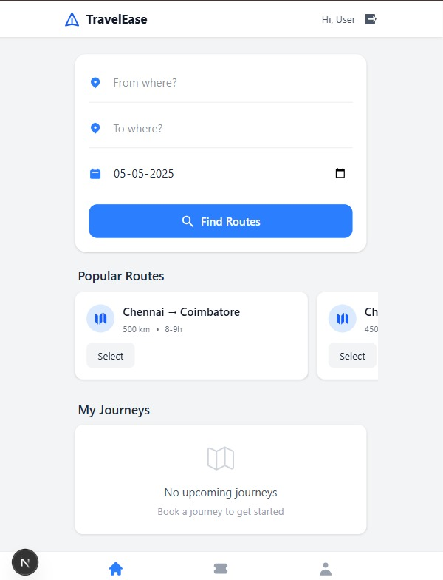

Login Page:

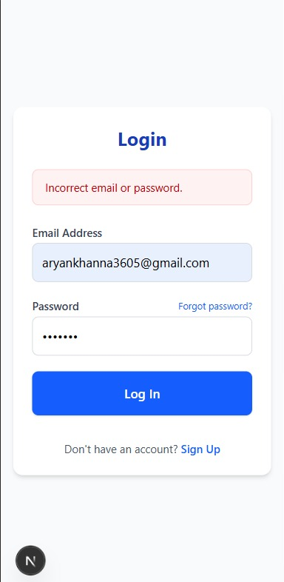
Available Routes :

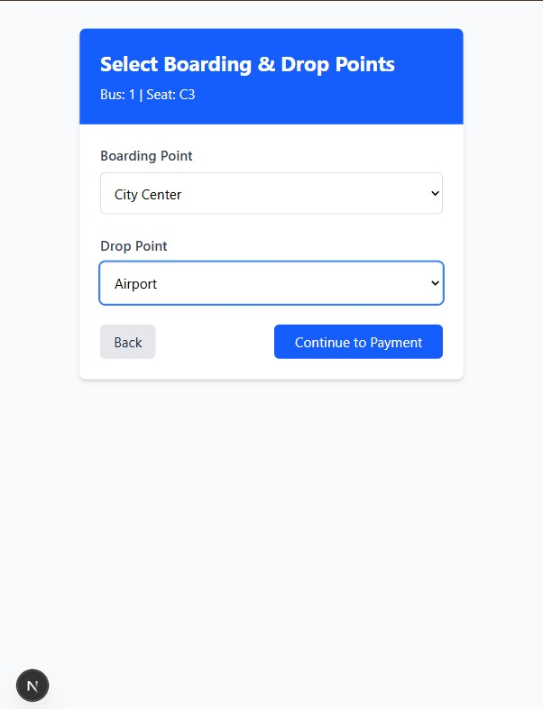

Select Boarding & Drop Points:



Select Your Seat
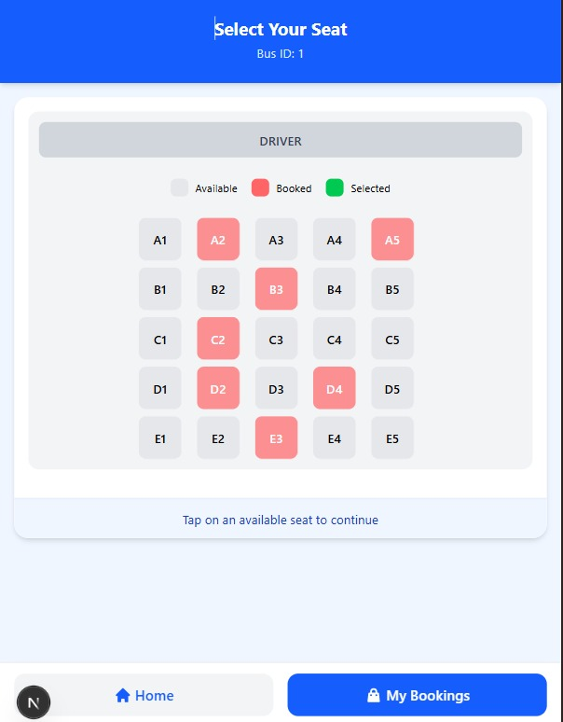

Payment

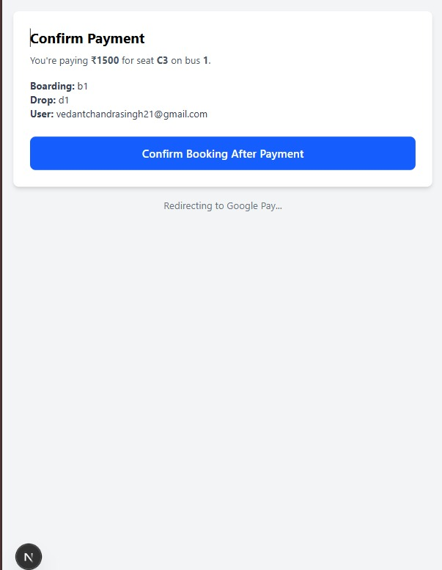

CONCLUSION

The Roadway Management System is a comprehensive digital solution designed to streamline and optimize bus transportation services. This system effectively integrates multiple modules, including passenger management, bus and route information, ticketing, booking, payments, notifications, reviews, and cancellations into a centralized database structure.

By adopting an entity-relationship model, the system ensures clear mapping of real-world objects such as buses, routes, passengers, and tickets, resulting in efficient and accurate data management.

The relational schema derived from the ER model supports data integrity, consistency, and scalability. Each table has been designed with proper keys and constraints to ensure that the relationships between entities are maintained seamlessly. Users can easily check bus availability, make bookings, receive real-time notifications, and even submit reviews, all within one platform. Admins or service providers can analyse booking patterns, monitor cancellations, and manage route planning effectively.

One of the standout features of this system is its route optimization logic, allowing users to view the best available routes between different locations based on factors like seat availability, timing, and bus capacity. This enhances the overall user experience while also reducing operational inefficiencies.

In conclusion, this project is a robust and practical approach toward digitizing public transportation. It not only simplifies the process for passengers but also supports service providers in delivering timely and reliable services. With further enhancements such as mobile app integration and real-time tracking, this system holds great potential in contributing to smart urban mobility solutions.

REAL TIME PROJECT CERTIFICATE / ONLINE COURSE CERTIFICATE

